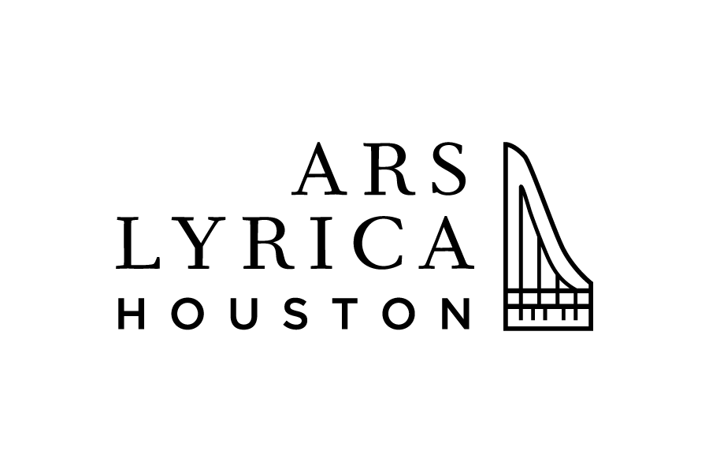

Media Contact:
PRESS RELEASE Lauren Miller,
For Immediate Release Tel: 713.622.7443
lmiller@arslyricahouston.org

ARS LYRICA HOUSTON ANNOUNCES
2019/20 SEASON “NATIONAL TREASURES”

Highlights include The New York Baroque Dance Company, the 14th annual New Year’s Eve celebration, a multimedia production celebrating Francisco Goya, and a solo harpsichord recital by Artist Director Matthew Dirst

Season explores iconic moments in diverse European cultures

Houston, TX, April 1, 2019— Ars Lyrica Houston, the Grammy nominated early music ensemble, celebrates its 15th-year anniversary with the announcement of the 2019/20 season entitled “National Treasures.” This season explores iconic moments in diverse European cultures, from Venice in the late 17th century through Madrid in the early 19th century. With a range of musical styles and genres accompanied by dance, visual art, and dramatization, this season illuminates defining moments in French, Italian, English, German, and Spanish cultural history.
Dancing at the Palais opens the season with a full Baroque orchestra of strings and winds plus the return of The New York Baroque Dance Company with Catherine Turocy as artistic director. This program includes instrumental suites from two vibrantly colorful French Baroque operas, both first seen at the Palais-Royal in Paris. Period choreography, paired with period instruments, recreates a refined artform that was de rigueur throughout Europe during the 17th and 18th centuries. The suites featured on this program include the American premiere of dance music from André Campra’s Hésione plus suites from Les Indes Galantes by Jean-Philippe Rameau. A pioneer in historical choreography, dance technique, and stage movement, Turocy has directed numerous highly acclaimed productions of Baroque operas in the US and in Europe. She returns to Houston during the 2020/21 season for a new production of Purcell’s Dido and Aeneas, Ars Lyrica’s second full-length Baroque opera.
The season continues with Handel in Love. Amorous duets, arias, and instrumental works mix freely on this tribute to the Baroque era’s finest musical dramatist. A truly cosmopolitan figure, George Frederic Handel combined a sturdy German musical heritage with sophisticated Italian training, in works that remain emblematic of his adopted English home. Soloists for this program include soprano and Rice University graduate Joanna Latini, tenor Richard Trey Smagur of the Houston Grand Opera Studio, and Baroque oboe virtuoso Kathryn Montoya.
On New Year’s Eve 2019, Ars Lyrica celebrates the legacy of Antonio Vivaldi and his Venetian predecessors with Venetian Carnival, a program of flamboyant concerts for flute, violin, and multiple instruments. Featured artists include Baroque flautist Colin St-Martin and Baroque violinists Elizabeth Blumenstock (longtime concertmaster of Philharmonia Baroque) and rising star Alana Youssefian. This festive evening begins with a three-course dinner and concludes with a lively post-concert party.
The turbulent environment of the Spanish artist Francisco Goya takes center stage in the production of Goya’s World: Reflexión y Revolución. This multi-media event includes projections of Goya’s artwork alongside performances of lively instrumental and vocal music by his contemporaries, including works by Francisco Courcelle, Fernando Sor, Vincente Garviso, as well as one of Luigi Boccherini’s guitar quintets. “Francisco Goya was a man of contrast and conflict. In his paintings he depicted all aspects of late 18th and early 19th century Spanish life: the leisure class enjoying a day on the banks of the Rio Manzañeras, a traditional bullfight, a tavern brawl, common people dancing a bolero or fandango, poverty, military might, royal majesty (albeit sometimes as a parody) and, most deliberately, the horrors of war”, says curator and guest director Richard Savino. A guitarist and lutenist, Savino is joined by mezzo-soprano Cecilia Duarte and a string ensemble led by violinist Adam LaMotte.
As a special treat offered exclusively to full-season subscribers and guests, Artistic Director Matthew Dirst performs a recital entitled Bach on Harpsichord at the Shepherd School of Music’s Duncan Recital Hall at Rice University. This exceptional event, the first Ars Lyrica program in many years to spotlight Dirst as a solo artist, features Bach’s iconic “Italian Concerto” and two of his most sumptuous French dance suites for harpsichord.
The season finale, entitled Bach Goes Greek, brings the full ensemble to the stage along with six outstanding singers for an evening of Bach cantatas with characters drawn from Greek mythology. Bach and his librettist turned the legendary competition between Phoebus (Apollo) and Pan into a lively singing contest, one Ars Lyrica recreates in modern dress for its 2019/20 season finale. Tara Faircloth directs Bach’s comic masterpiece and Matthew Dirst conducts. This program features soprano Dominique McCormick, countertenor Aryeh Nussbaum Cohen, tenors Derek Chester and Christopher Bozeka, and baritones Thomas Glass and Mark Diamond.
Subscriptions for Ars Lyrica Houston’s 2019/20 season are on sale now. To purchase tickets or view the season brochure, please visit www.arslyricahouston.org or call the Hobby Center for the Performing Arts Box Office at 713.315.2525 (Press 4 for Ars Lyrica Houston).

Founded in 1998 by harpsichordist and conductor Matthew Dirst, Ars Lyrica Houston presents a diverse array of music from the 17th and 18th centuries on period instruments. Its local subscription series, according to the Houston Chronicle, “sets the agenda” for early music in Houston and it also appears regularly at major festivals and conferences, including the 2014 Berkeley Early Music Festival & Exhibition. Ars Lyrica’s distinctive programming favors Baroque dramatic and chamber works, and its pioneering efforts have won international acclaim.

For high-resolution images and artist bios, please use this link: http://bit.ly/ALH1920

Ars Lyrica Houston’s 2019/20 Season: National Treasures

Season Calendar

Dancing at the Palais
Featuring The New York Baroque Dance Company
Friday, September 20, 2019 at 8:00 pm
Zilkha Hall, Hobby Center for the Performing Arts

7:15 pm pre-concert lecture with Catherine Turocy (New York Baroque Dance Company) and John Powell (University of Tulsa)
- André Campra, Suite from Hésione (ed. John Powell)
- Jean-Philippe Rameau, Suites from Les Indes Galantes

Handel in Love
Featuring Joanna Latini, soprano; Richard Trey Smagur, tenor; Kathryn Montoya, baroque oboe
Saturday, November 23 at 7:30 pm
Zilkha Hall, Hobby Center for the Performing Arts

- Cecilia, vogli un sguardo for soprano, tenor, and strings, HWV 89
- “As steals the morn” from L’Allegro, il Penseroso ed il Moderato, HWV 55
- Oboe Concerto in G Minor, HWV 287

Venetian Carnival
Featuring Elizabeth Blumenstock & Alana Youssefian, violin; Colin St-Martin, traverso
Tuesday, December 31 at 9 pm
Zilkha Hall, Hobby Center for the Performing Arts

- Pre-Concert Dinner at Hobby Center’s Diana Restaurant at 7:30 pm
- Venetian Carnival Concert at Zilkha Hall at 9:00 pm
- Post-Concert Party at Hobby Center’s Diana Restaurant at 10:30 pm

Goya’s World: Reflexión y Revolución
Featuring Richard Savino, guitarist & guest director; Cecilia Duarte, mezzo-soprano; Adam LaMotte, violin
Saturday, February 22 at 7:30 pm
Zilkha Hall, Hobby Center for the Performing Arts

Bach on Harpsichord
Featuring Matthew Dirst, harpsichord
Saturday, March 14 at 6 pm
Duncan Recital Hall, Shepherd School of Music at Rice University

- “English” Suite No. 2 in A Minor, BWV 807
- Concerto in the Italian Style, BWV 971
- Partita IV in D Major, BWV 828

Bach Goes Greek
Featuring Dominique McCormick, soprano; Aryeh Nussbaum Cohen, countertenor; Derek Chester & Christopher Bozeka, tenor; Thomas Glass & Mark Diamond, baritone
Saturday, May 16 at 7:30 pm
Zilkha Hall, Hobby Center for the Performing Arts

- Phoebus & Pan, BWV 201
- Tönet ihr Pauken, BWV 214

